# **Plotting**

Task 1 (Manual Histogram)

Create a histogram of a grayscale image manually using Matplotlib (you can load an RGB image and convert it to grayscale), without using the OpenCV built-in function cv2.calcHist. Instead, you are to create an array of 255 locations, initially zeroed. Use *ravel()* function to flatten the image and hist() function to display your plot in 256 bins. Each of these locations corresponds to a count of pixels at a particular intensity level (location 1 is black, 255 is white,…) Display the original grayscale image and the histogram next to each other as follows:

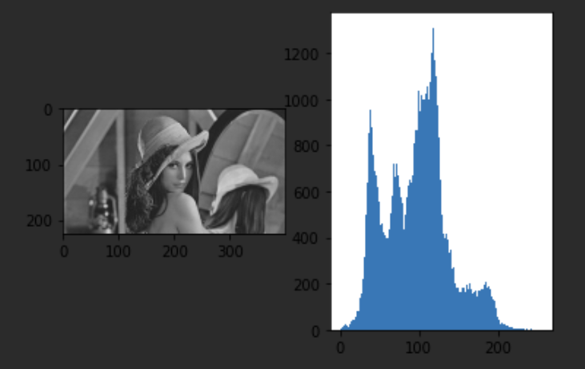

In the same figure try plotting the histogram automatically by using the *calchist*  command and compare the two results from the two different functions.

Task 2 (Marking black pixels in grayscale image)

1. Create a new drawing with Microsoft Paint. In it include a few black dots. Save it as a 256-colour bitmap.
2. Create a new python file, and load the bitmap as a grayscale image. Display it in a new figure.
3. Loop through all the pixels in the image to find the ones that are black (luminance 0). Use the following commands to draw red circles on the image around the black pixels:   
     
   *cv2.circle(img, center=(y,x), radius=10, color=(255,0,0), thickness=3)*
4. Keep a count of all the black pixels and display it on the figure afterward (e.g. bottom right corner) using the following code.

*label = 'No of pixels: ' + str(count)  
cv2.putText(img, label, (10,30), cv2.FONT_HERSHEY_SIMPLEX, 1, (255,0,0), 2)*

The output should look somewhat as follows:

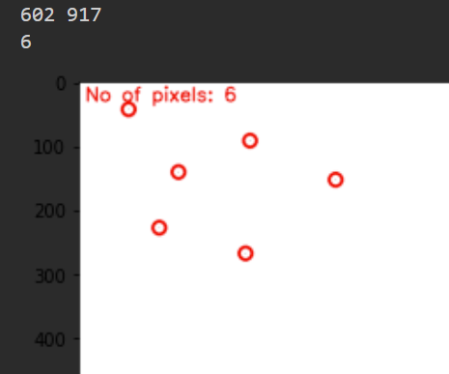

Task 3 (Marking red, green, blue pixels in an RGB image)

1. Create a new Python file, and generate a random RGB image 15 pixels wide by 15 pixels long. Each pixel can have a value of red which is 0 or 255, a value of blue which is 0 or 255, and a value of green which is 0 or 255. Display it in a new figure.

Thus the only colours that can be generated are the following:

* White (255,255,255)
* Black (0,0,0)
* Red (255,0,0)
* Green (0,255,0)
* Blue (0,0,255)
* Yellow (255,255,0)
* Magenta (255,0,255)
* Cyan (0,255,255)

1. Loop through all the pixels in the image and circle the red pixels with red circles, the blue pixels with blue circles, and the green pixels with green circles.
2. Keep a count of all the red, blue and green pixels separately and display the info on the figure afterward.

The output should look somewhat as follows:

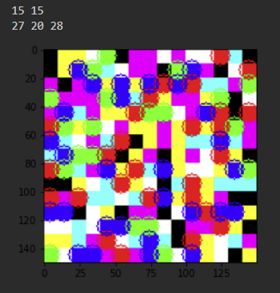  
Hint: resize the image so you can display output at 150x150 px